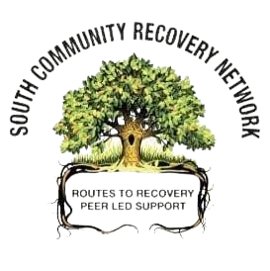
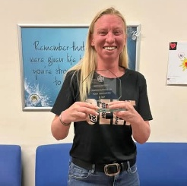
Good News Story
Marrisa
I first engaged with the South Community Recovery Network in 2020 through engaging with their then Outreach worker Anna Campbell.
I had recently just come into recovery after using substances for the best part of 30 year both illegal and prescribed drugs. At the time we were in a lock down so face to face meetings and recovery cafes had all went onto the zoom platform in which Anna was able to source an iPad for me to get connected onto zoom every day, which was major in maintaining my recovery at the time.
I engaged with them daily and started to build connections. When the SCRN opened their drop in cafes after lockdown I started to go out and participate alongside going to fellowship meetings. I got involved with everything the SCRN had to offer and started to volunteer and go through the pathways from local, south to lead volunteering and onto becoming Chair to one of their recovery cafes.
During my 3 ½ years volunteering with them I was encouraged to also join a day program and to apply for a Cosca Counselling course, given loads of training opportunities that I got involved in and was given the opportunity to do a SVQ3 in Social Services and Health Care and have been supported from both staff and volunteers.
They also supported me in the building of better healthier relationships with my 3 children, my mum and my 3 brothers.
Through taking on all the opportunities and the work I have done on myself I managed to secure full time employment in a job that I love, helping others at the start of their recovery journey.
I have great relationships with my 3 children and my mum and have recently become a gran for the first time to my we grandson.
I continue to use the support from the staff and volunteers who have now became my closest friends and network.

