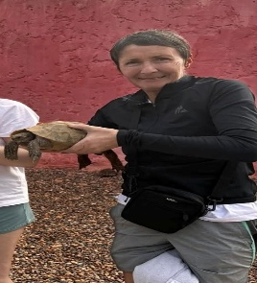
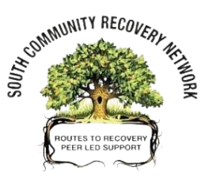
Good News Story
Rena
I first heard about the South Community Recovery Network through attending fellowship meetings. In October 2025 I began going to the Women’s Group in the Gorbals and from there I became a regular participant at all the cafes and groups that the SCRN have.
I had only been in recovery 2 months prior to this after 45 years of using drugs and 35 years on prescription drugs. I had tried to stop using several times in the past through attending rehabs and detox centres however I didn’t understand anything about connection which is vital when trying to recover once you leave these services.
The staff, volunteers and other participants at the SCRN gave me support and showed belief in me when I didn’t believe in myself. Thanks to them and fellowship meetings I haven’t used any drugs and have managed to come off methadone after 35 years!
I will celebrate my first day clean on 21st March. Yayyy!!
Attending the South Community Recovery Network is now part of my daily routine. I have met lots of good people and made new friends and connections.
I enjoy doing different activities at the cafes such as arts & crafts, groupwork sessions, bingo and the quizzes.
I tell everyone about the SCRN and encourage everyone I meet to go along and get involved.
I now also volunteer at Turning Point Scotland after completing a 12 week course with them. I go into the Crisis Centre & Stabilisation Unit no longer as a service user but as a volunteer helping to facilitate groups. I also accompany service users from Move On to fellowship meeting and recovery cafes.
I am buzzing to say I am going my first ever holiday drug free with people I have met through recovery, that I now get to call my friends.

